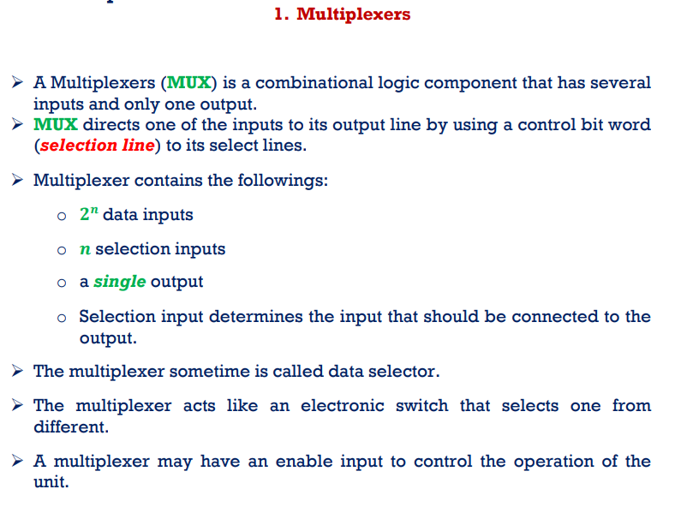
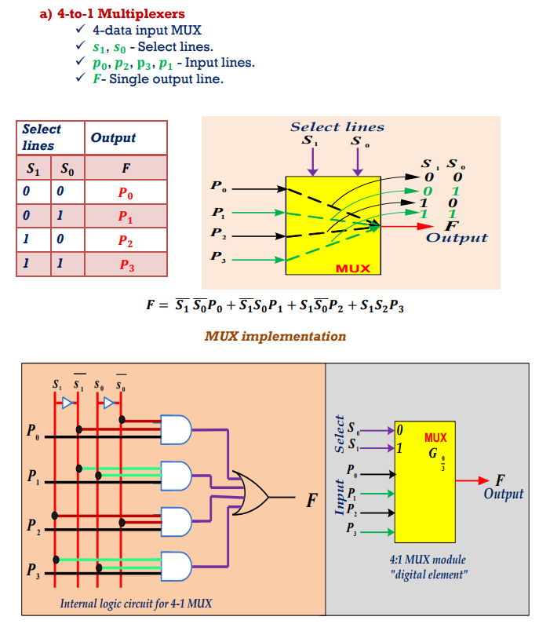
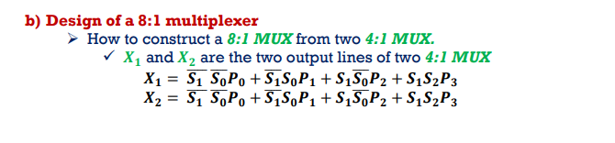
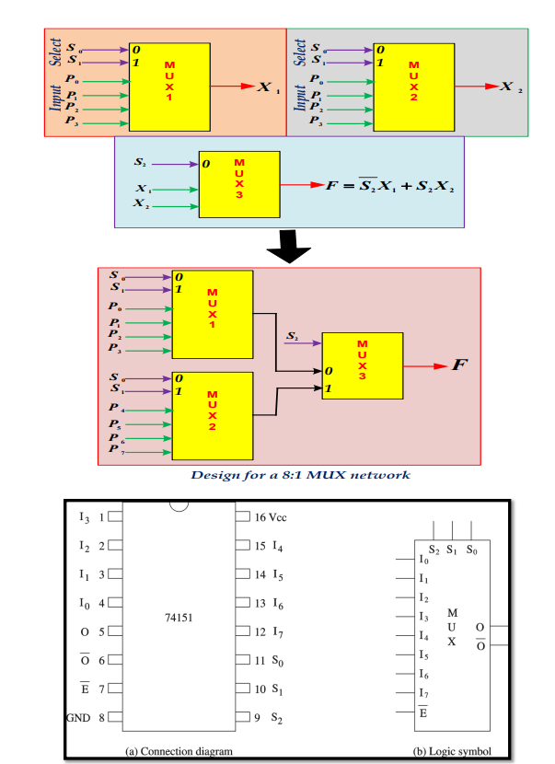
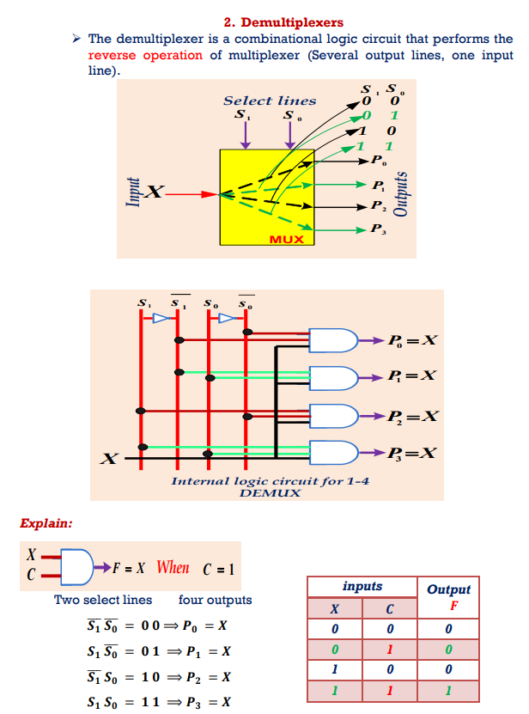
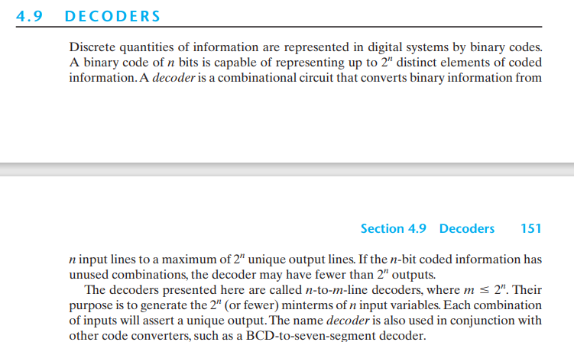
Three-to-eight-line decoder circuit: decoder is binary-to-octal conversion
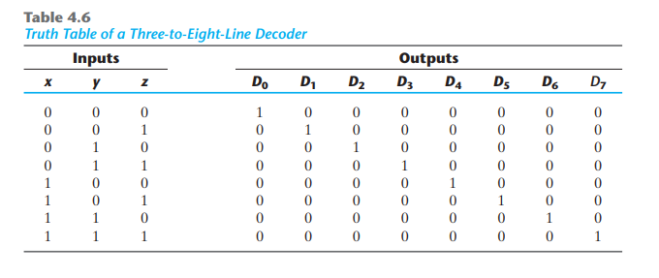
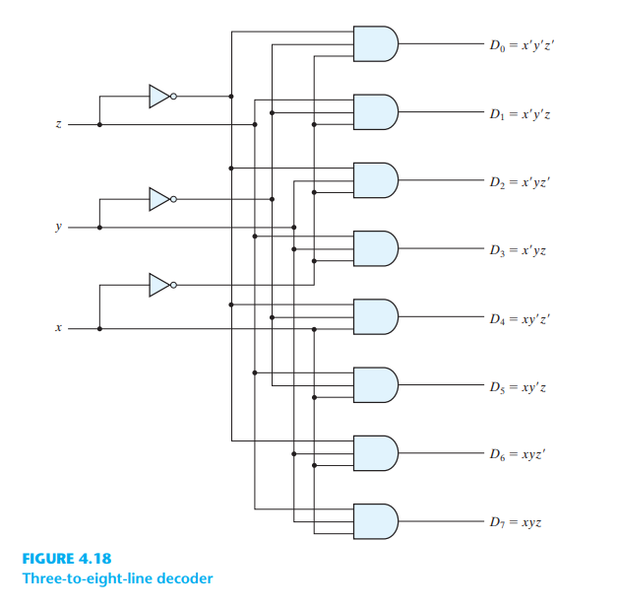
two-to-four-line decoder with an enable input constructed with NAND gates
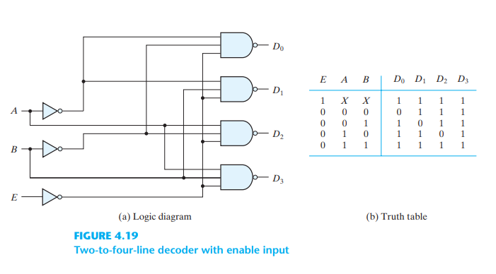
A decoder with enable input can function as a demultiplexer—when E is taken as a data input line and A and B are taken as the selection inputs. Because decoder and demultiplexer operations are obtained from the same circuit, a decoder with an enable input is referred to as a decoder – demultiplexer .
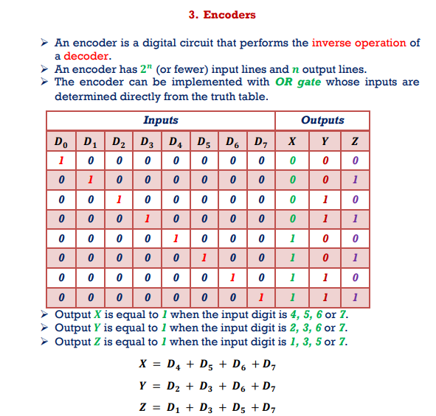
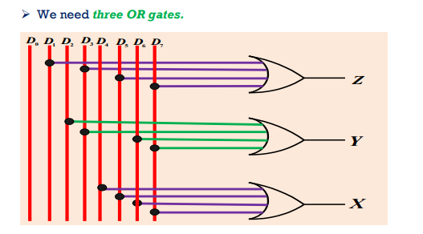
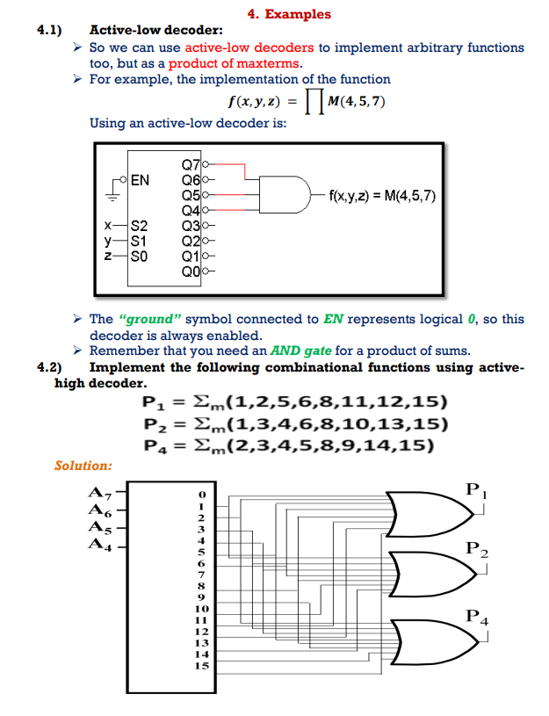
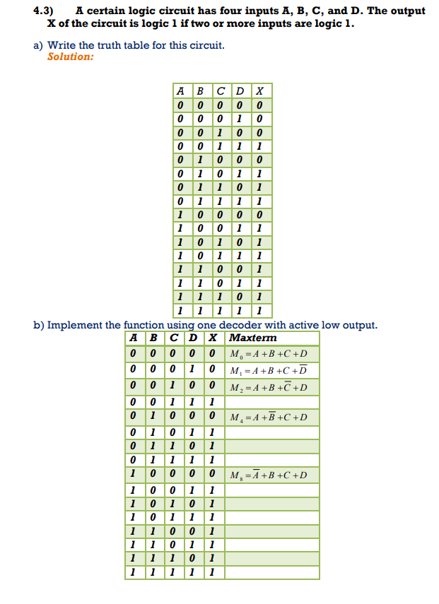
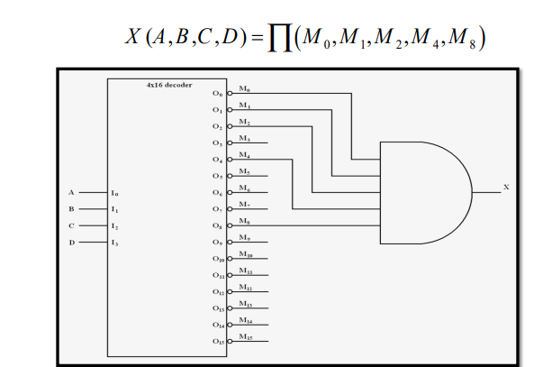

Application of decoder:
Binary to Octal 3x8
Binary to Hexadecimal 4x16
Binary to decimal 4x10

Application of encoder:
- 4 to 2 Encoder
- Octal to Binary Encoder (8 to 3 Encoder)
- Decimal to BCD Encoder
- Priority Encoder
Encoder in Digital Logic
https://www.geeksforgeeks.org/encoder-in-digital-logic/?ref=lbp

